CREATIVE EDUCATIONAL SERVICES

BEGINNING OF TERM II EXAMINATION 2024

LITERACY IB

PRIMARY ONE

DURATION: 2HOURS 15 MINUTES

**Name ______________________________________________________**

**Date _______________________________ Stream ________________**

**SCHOOL: ____________________________________________________**

1. Write the name of your school.

__________________________________________________________

1. Who cooks food at home**?**

**__________________________________________________________**

1. How do you come to school**?**

**__________________________________________________________**

1. Name these things you see on your way to school.

|  |  |  |  |
| --- | --- | --- | --- |
|  | https://encrypted-tbn0.gstatic.com/images?q=tbn:ANd9GcRWKIbNTkHzXmw9vwsybpOj-zRLr0AdlE53K8SRbUlwsNDyYq2_oQ | Description: Image result for a car for colouring |  |
|  |  |  |  |

1. Write the name of your headteacher.

__________________________________________________________

1. **Draw these things we find in the classroom.**

|  |  |  |  |
| --- | --- | --- | --- |
|  |  |  |  |
| book | chalk | ball | chair |

1. Why do we need brooms in a classroom**?**

**__________________________________________________________**

1. **Match these people to their places of work.**

teachers library

nurses office

cooks classroom

headteacher sickbay

librarian kitchen.

1. **Name these activities we do at school.**

|  |  |  |
| --- | --- | --- |
| C:\Users\hp\Pictures\p4 Science term ll diagram\p128a.gif |  | Description: Image result for someone reading a book for colouring |
|  |  |  |

(**reading , washing hands, sweeping**)

1. **Match these body parts and their uses.**

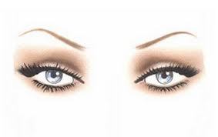

walking.

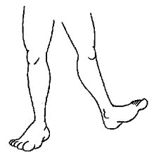

smelling

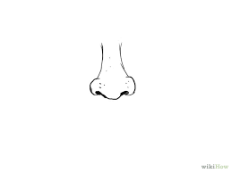

hearing

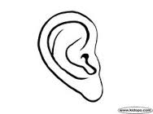

seeing

1. **Give the meaning of these names.**
2. Peter __________________________________
3. Grace __________________________________
4. Mukisa __________________________________
5. **Underlined two wild animals.**

cow, snake, cat, lion.

1. Name three things we use to write.

(a) ________________ (b) ________________ (c)_____________

(**broom, chalk, pencil, table, pen**)

1. What is this?
2. 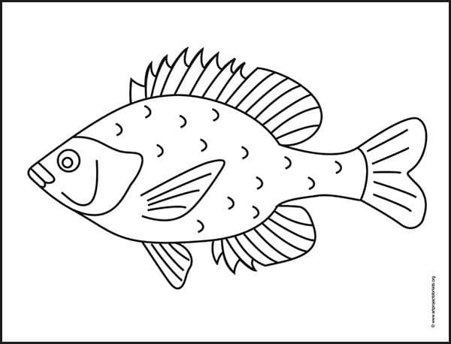That is a________________________________________________
3. Where does it stay? _____________________________________